**Jenkins and Git Integration**  
  
Visit github.com and log in.

Click on "New" to create a new repository.  
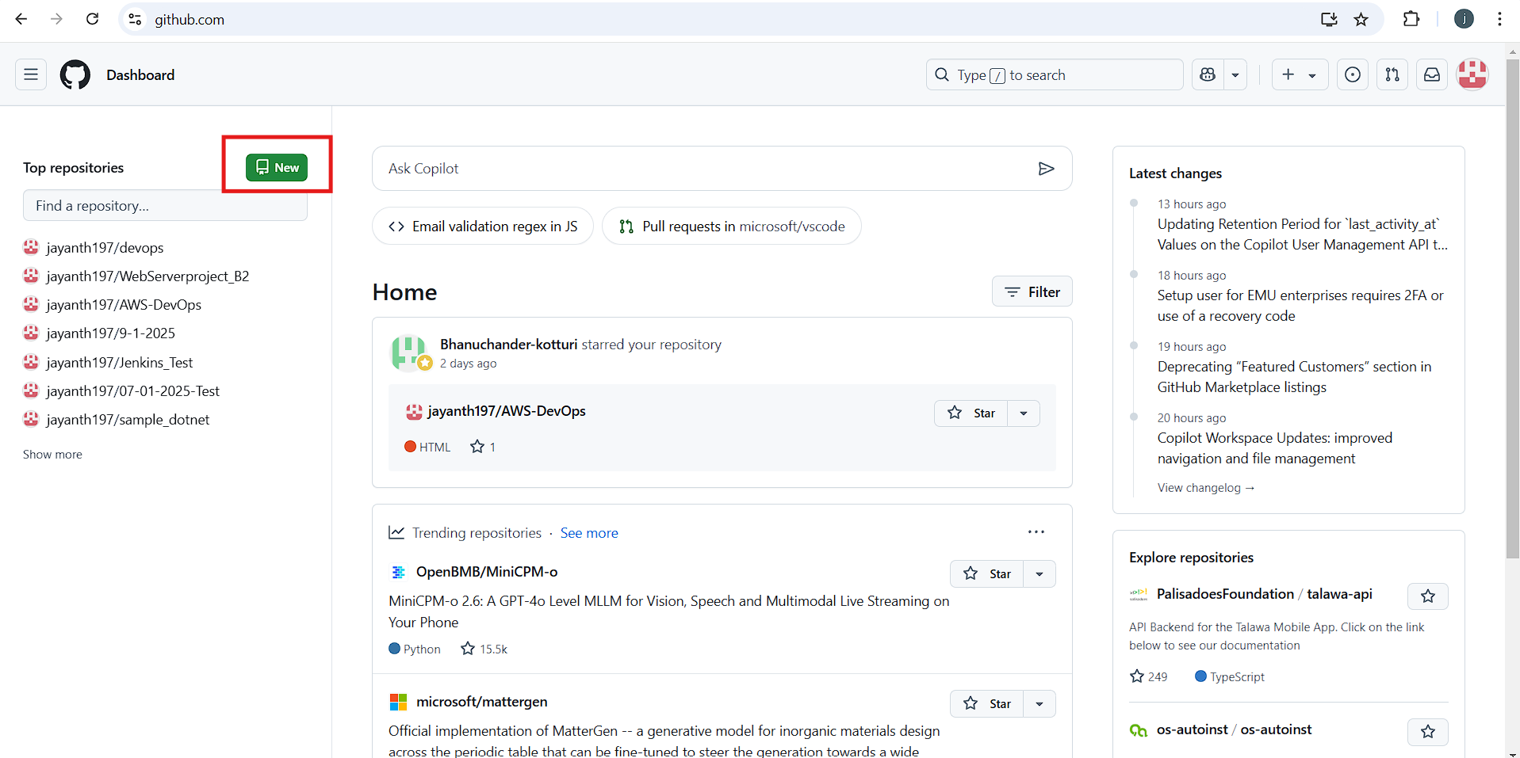  
  
  
Provide a repository name and description.

Select "Private" and click "Create" to set up your repository.  
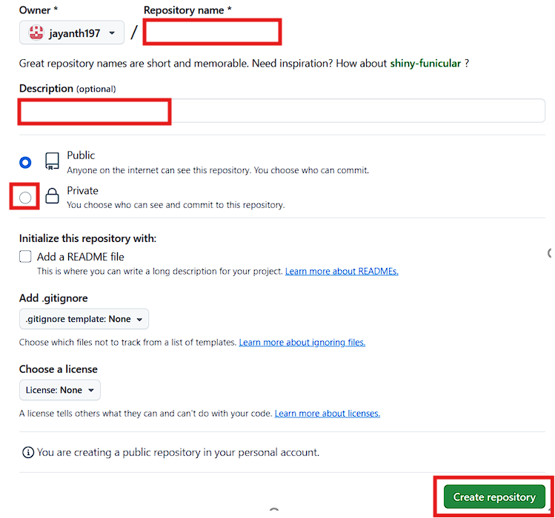   
  
  
Navigate to Settings > Developer Settings.  
  
  
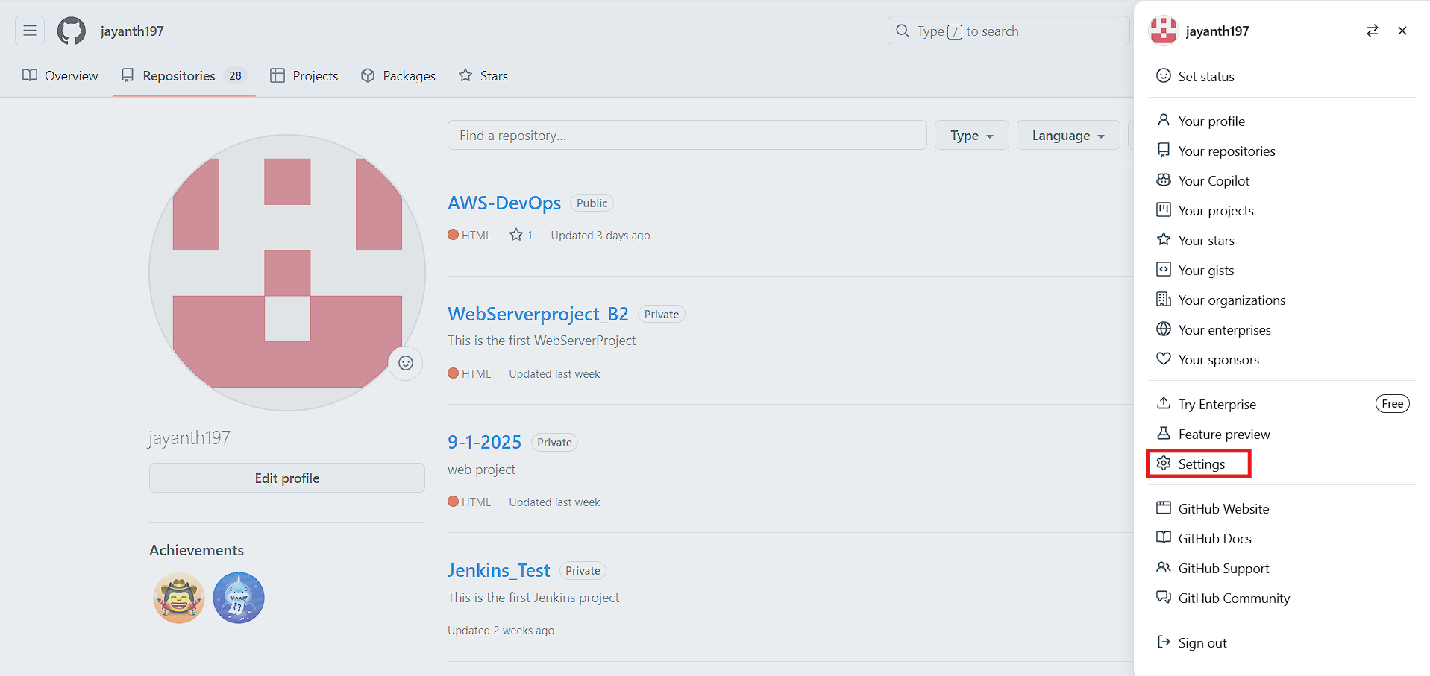  
  
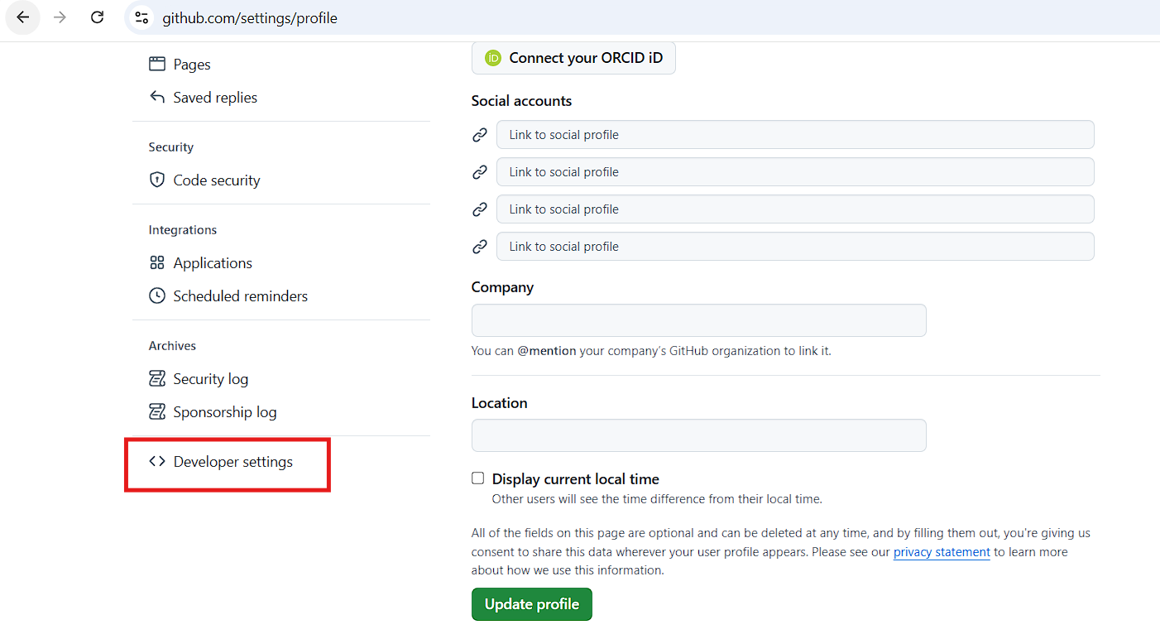  
Click on "Token (classic)" and select "Generate new token (classic)".

Enter your GitHub account password.  
  
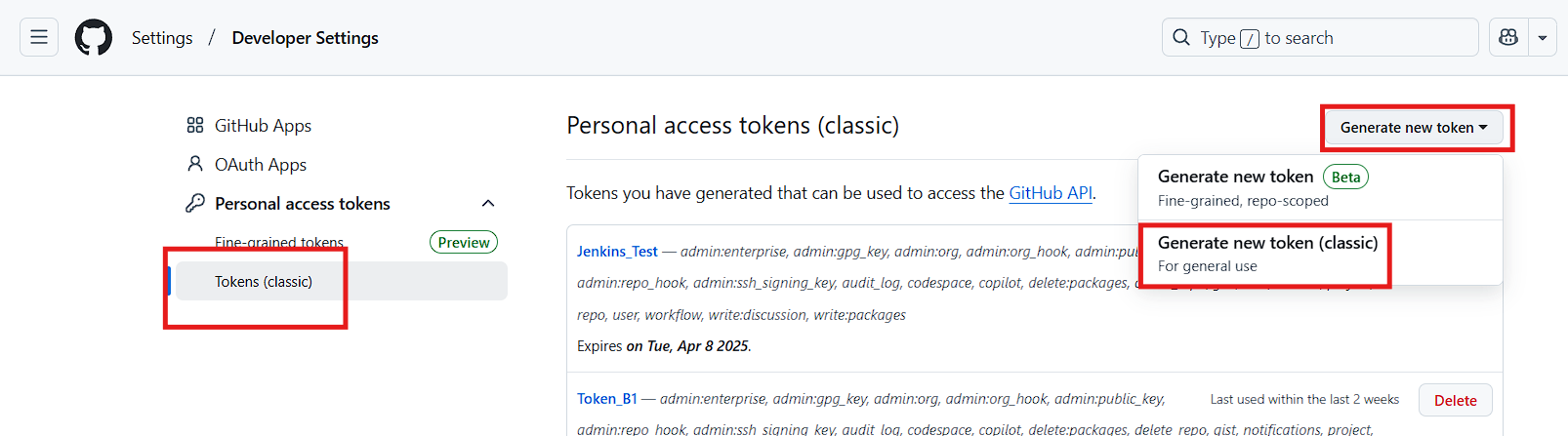  
  
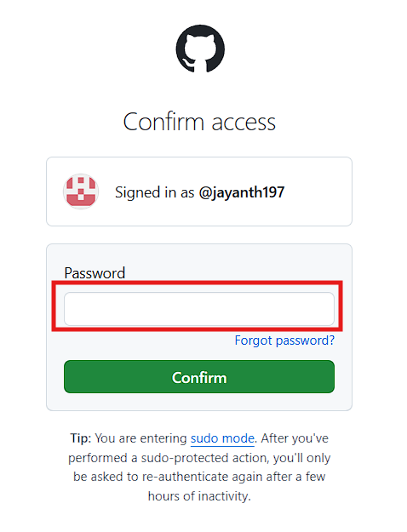  
  
Name the token, set the expiry to 90 days, select all options, and click "Generate".  
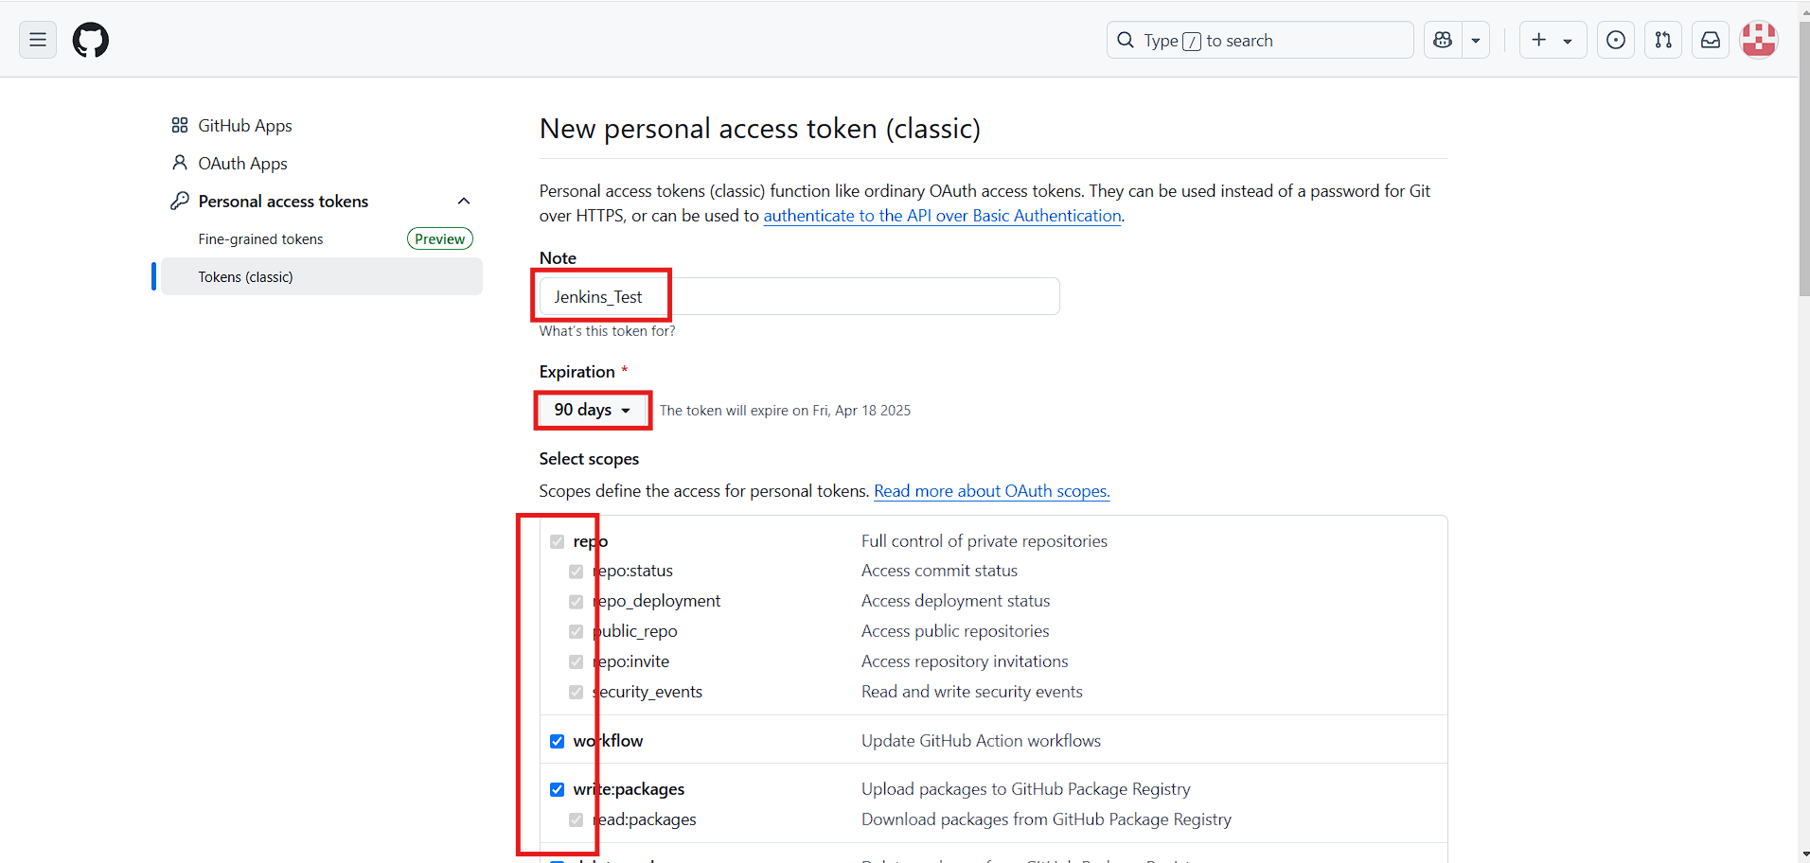  
  
  
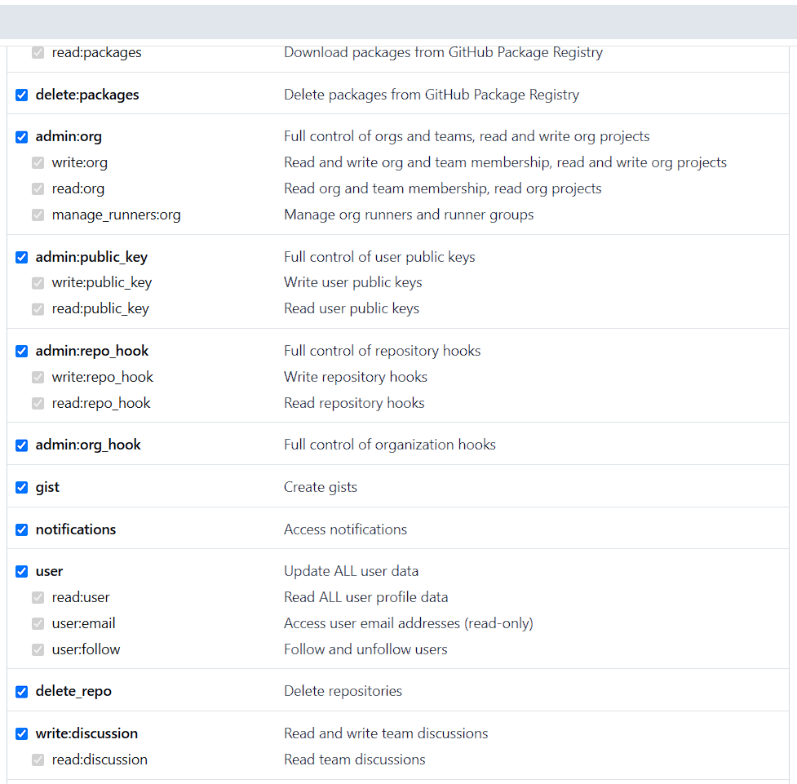  
  
  
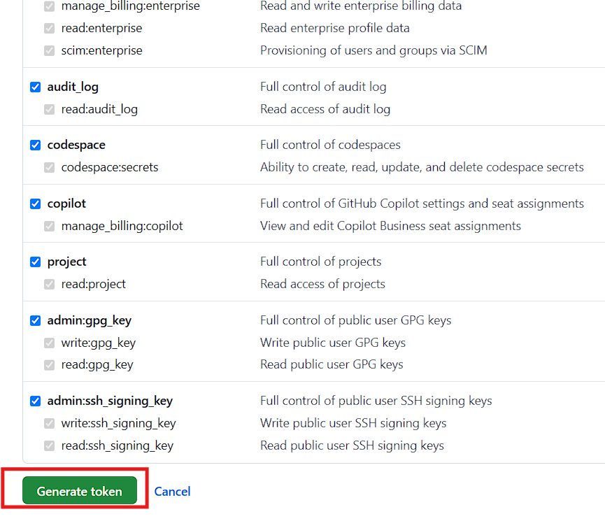  
  
Copy the token (it will be shown only once) and save it for Jenkins integration.  
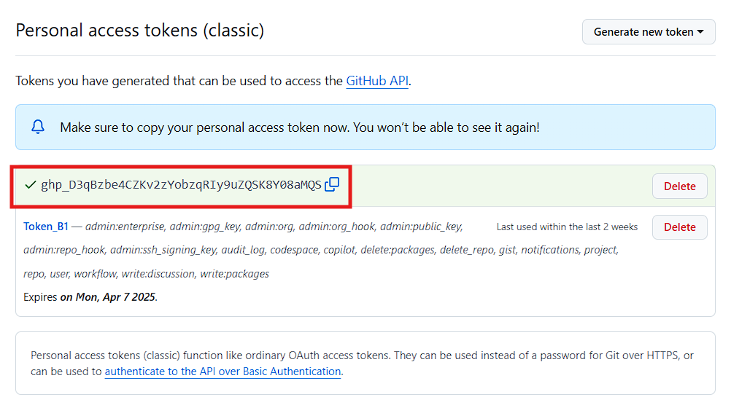  
  
  
  
Go to your repository and click on "Code" to copy the HTTPS URL.  
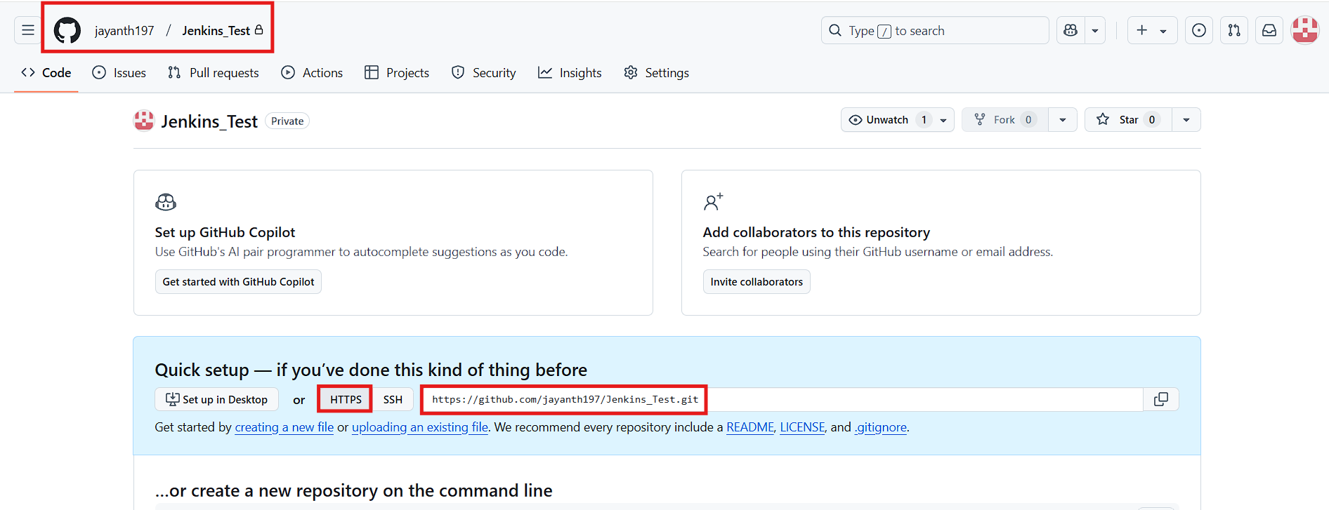  
  
  
Open Git Bash in the desired local path and clone the repository using git bash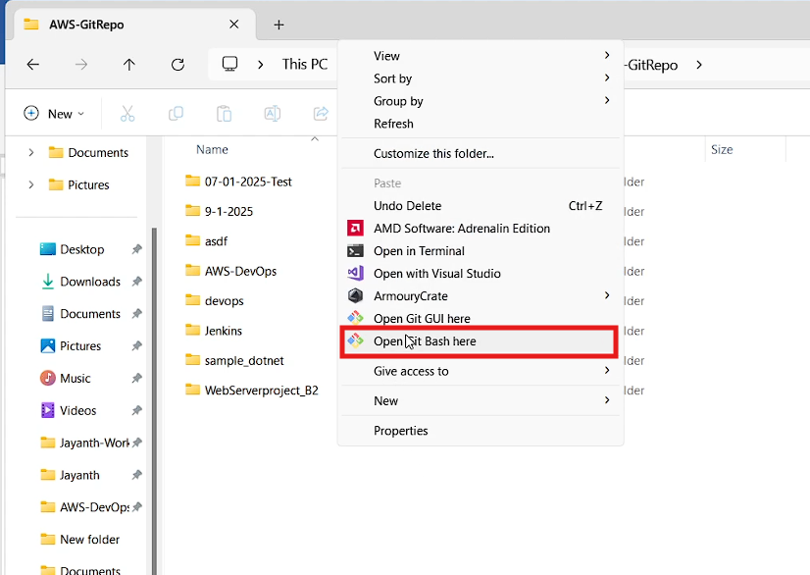  
  
  
  
  
  
entering the following command  
git clone  
  
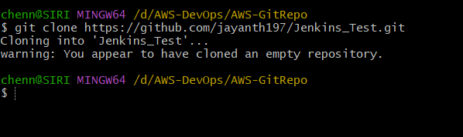  
  
To create files locally, you can use commands like touch 1.txt 2.txt 3.txt or clone an existing repository, e.g., https://github.com/jayanth197/AWS-DevOps.git.  
  
same way clone this repository in your local then you will see file like below  
  
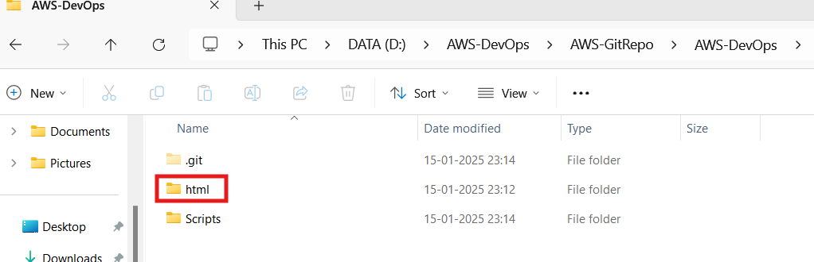  
  
in the html folder there are some html files copy those files and paste it into your cloned repository  
  
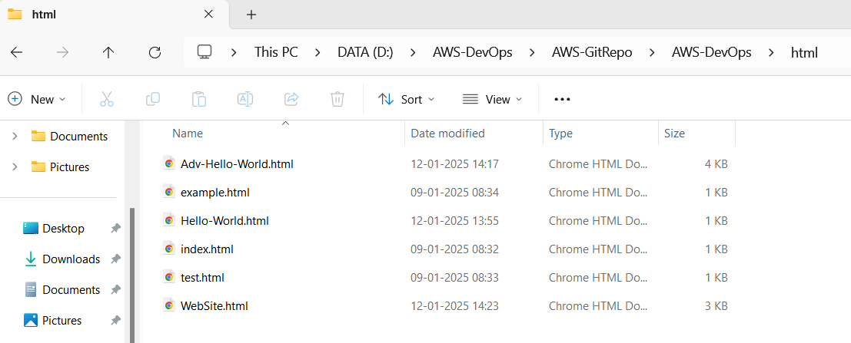  
  
  
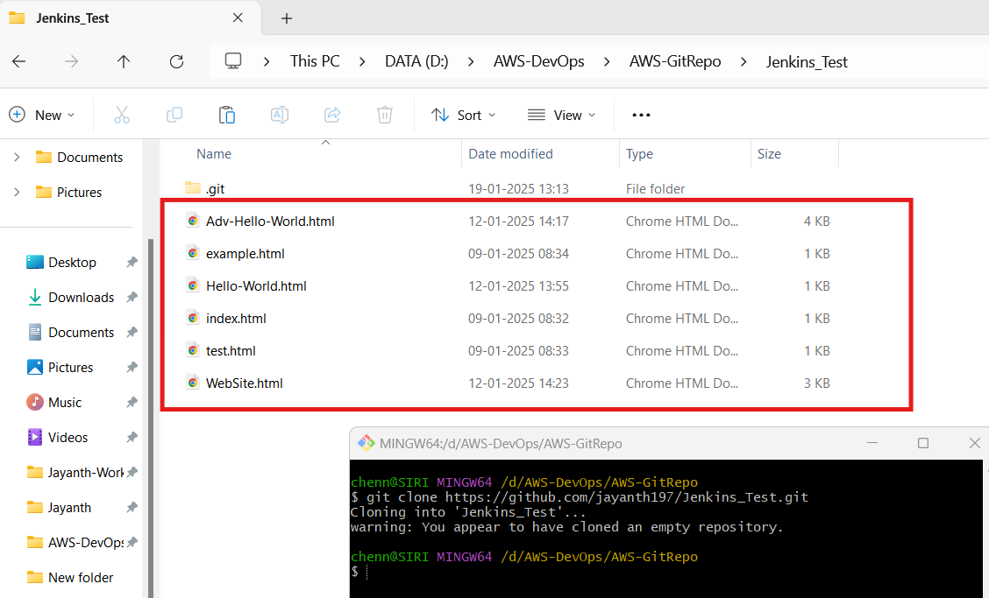  
  
  
Use the following commands to add, commit, and push the changes:  
git add .

git status

git commit -m "Test Files"

git push  
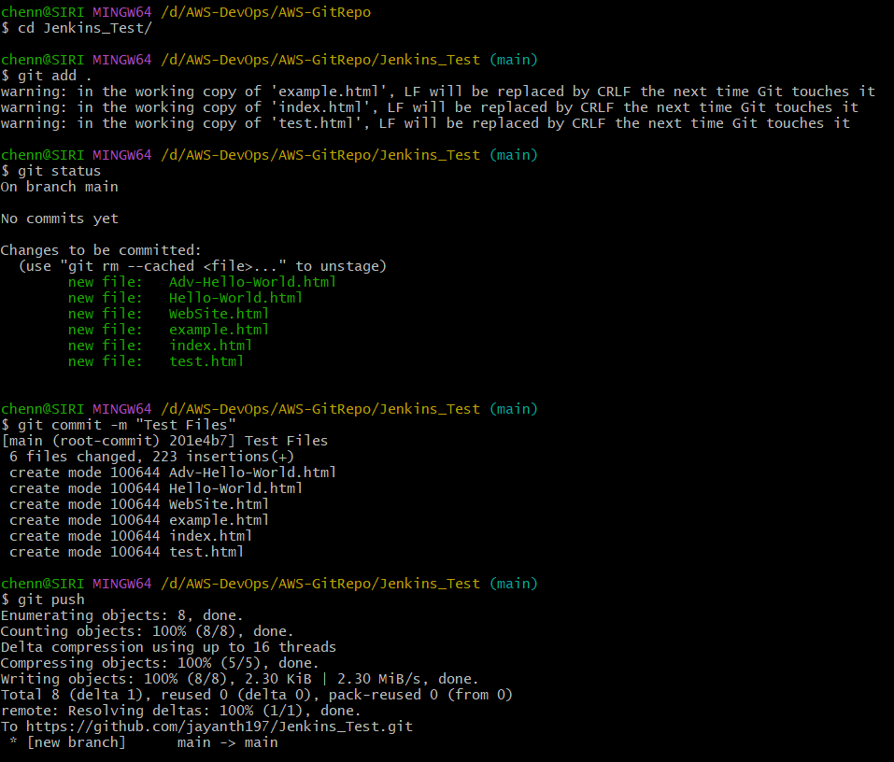  
now go to your repository then you will see the newly created files in the repository  
  
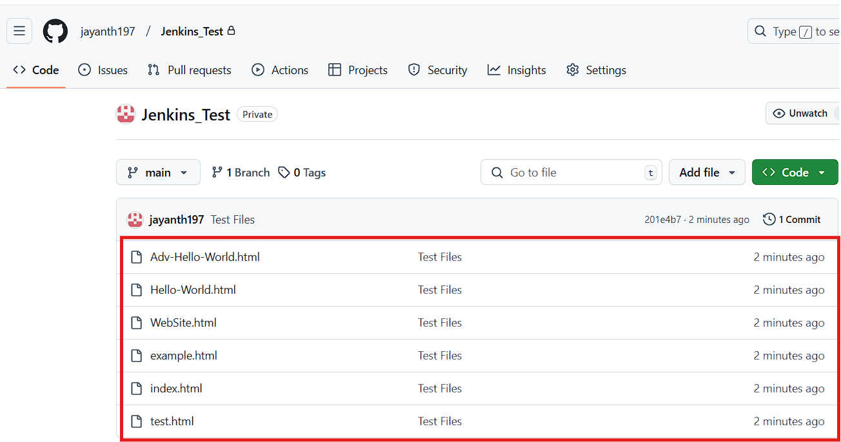  
  
Log in to the Jenkins dashboard.  
  
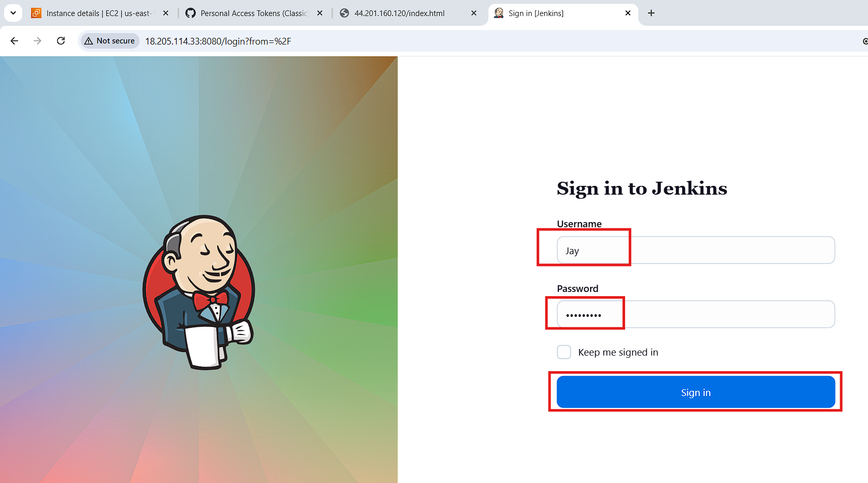  
  
Click on "New Item", enter a job name, select "Freestyle project", and click "OK".  
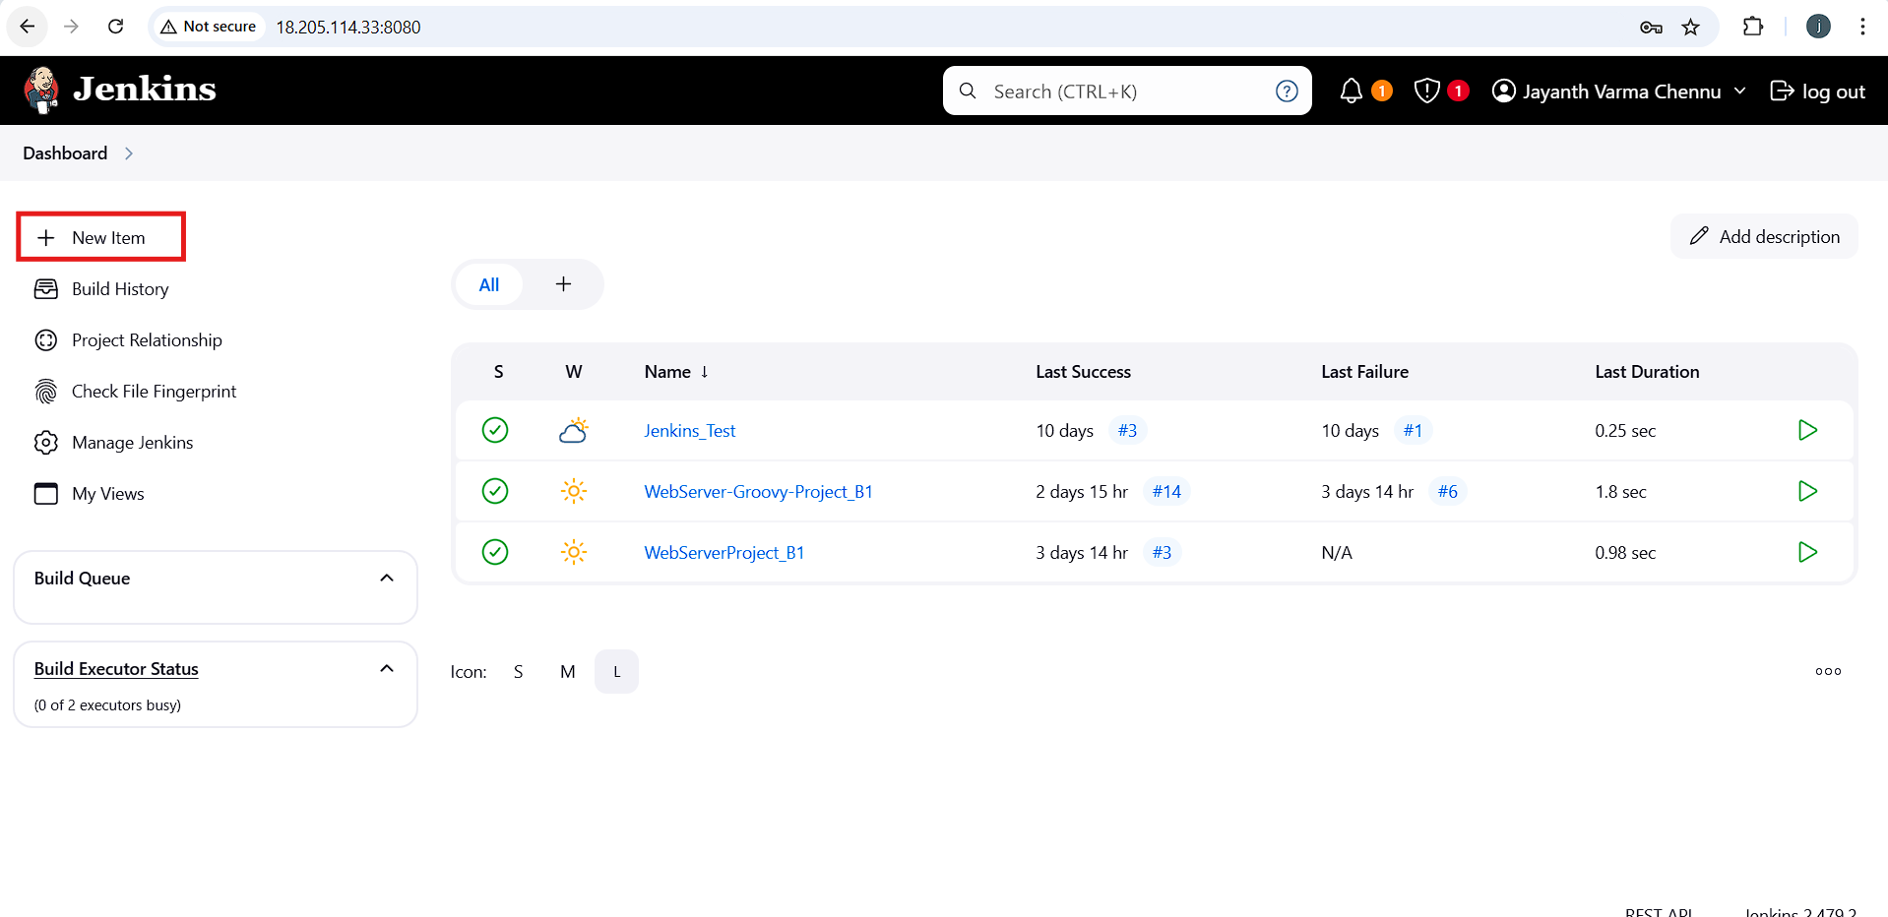  
  
  
  
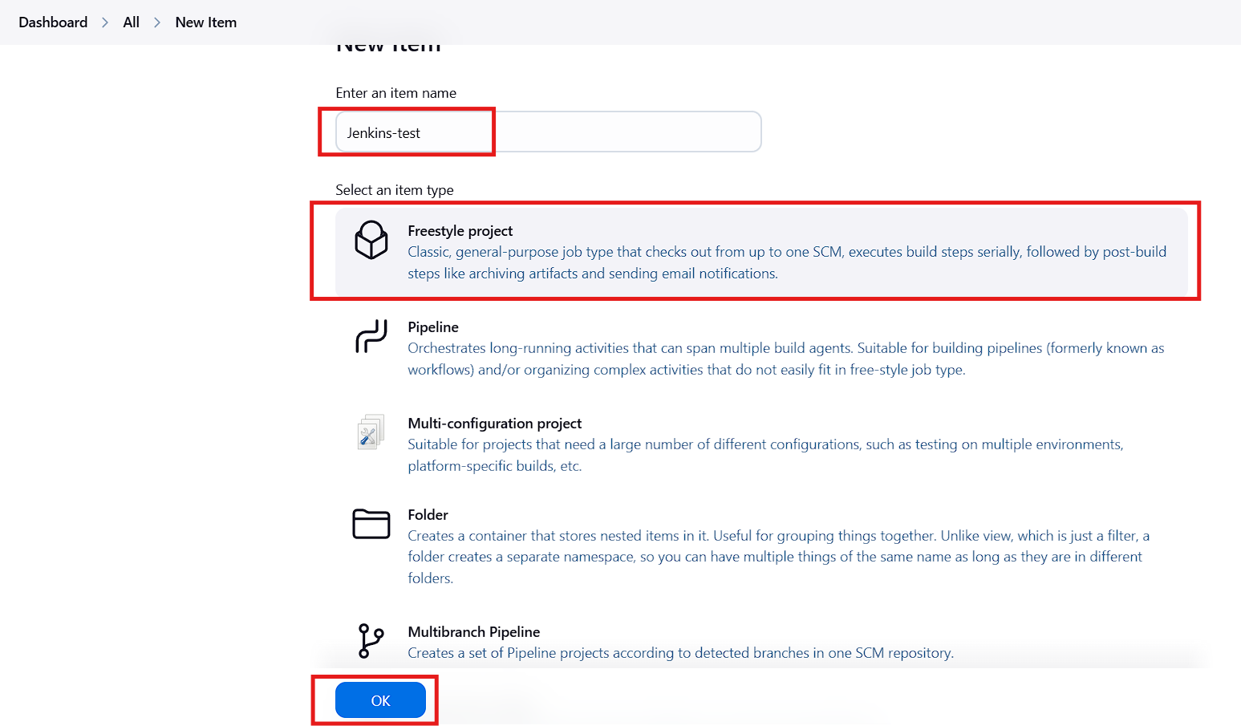  
  
  
  
  
  
  
  
  
  
  
In the git section paste you repository then you get some error  
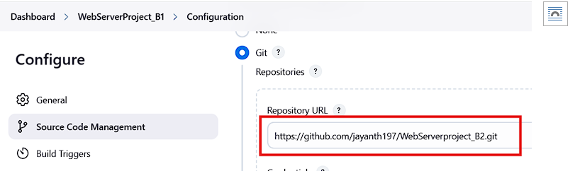  
  
  
install Git on the Jenkins server using the following commands:  
Verify the installation with git version.  
  
  
  
  
  
  
  
  
  
Click "Add", select "Jenkins”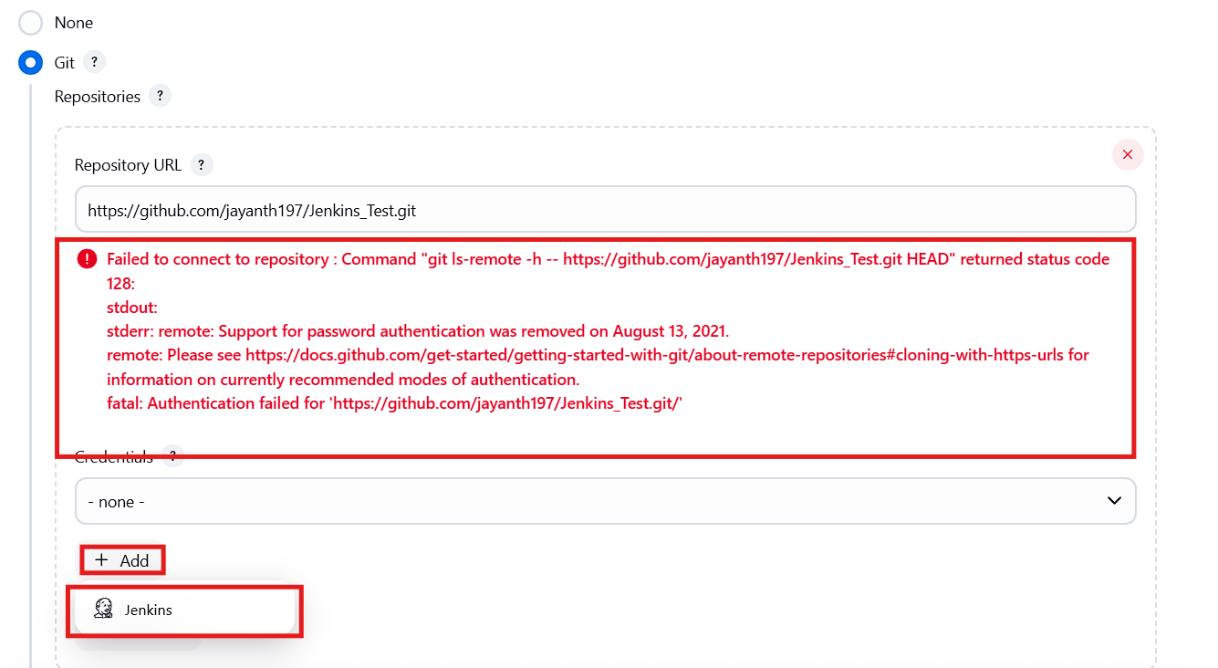  
  
Provide your GitHub account username, enter the PAT unique ID as the password (which we created previously in the GitHub account), add a description, and click 'Add'."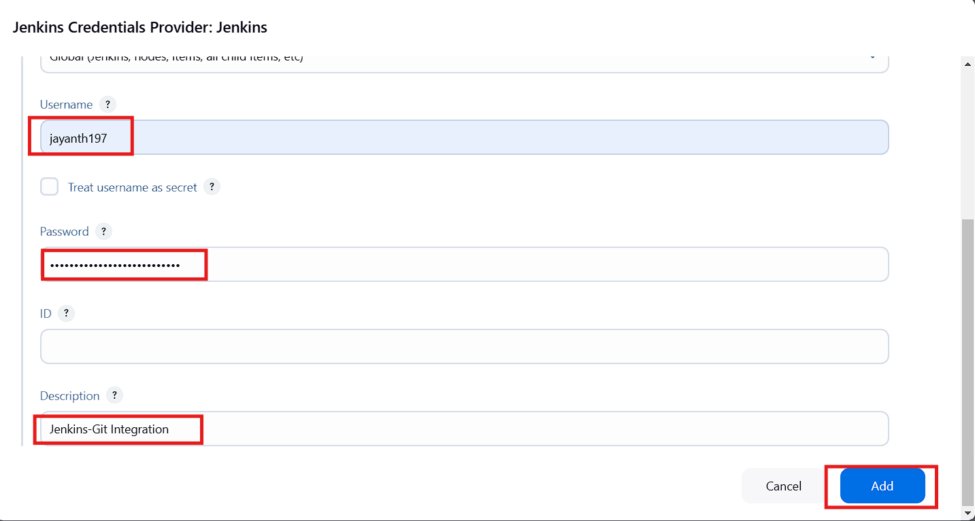  
  
Now, in the credentials section, select the credentials we created, specify the branch as */main, and click 'Apply' and 'Save'.  
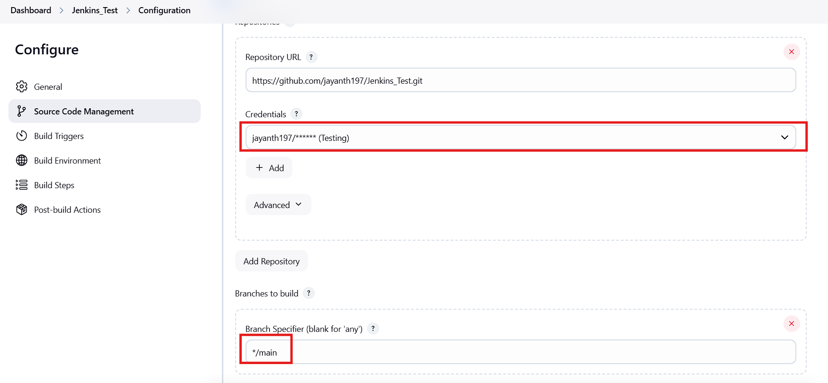  
  
  
  
Now, you will be redirected to the job page. Click on 'Build Now,' and you will see the job status as green, indicating that the job was successful.  
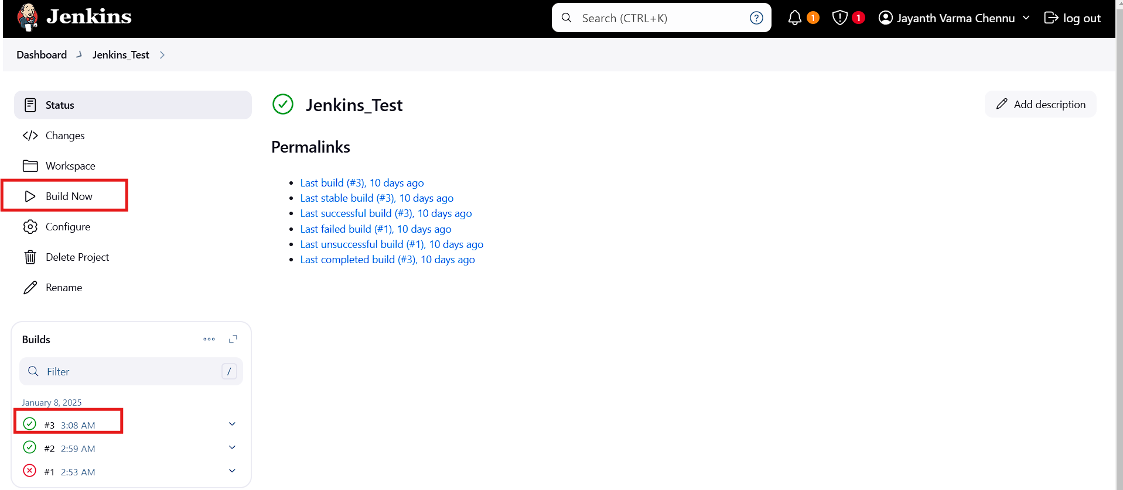  
Now, go to 'Manage Jenkins,' and in the build steps, click on 'Execute Shell.  
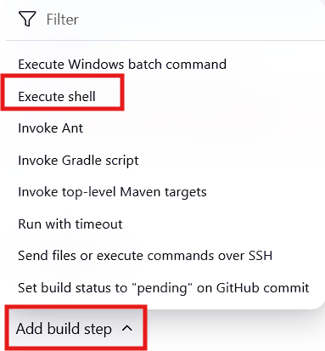  
  
Use the following commands, then click 'Apply' and 'Save':  
mkdir Test

cd Test

touch 1.txt abc.txt def.txt

echo "This is the first project in Jenkins"  
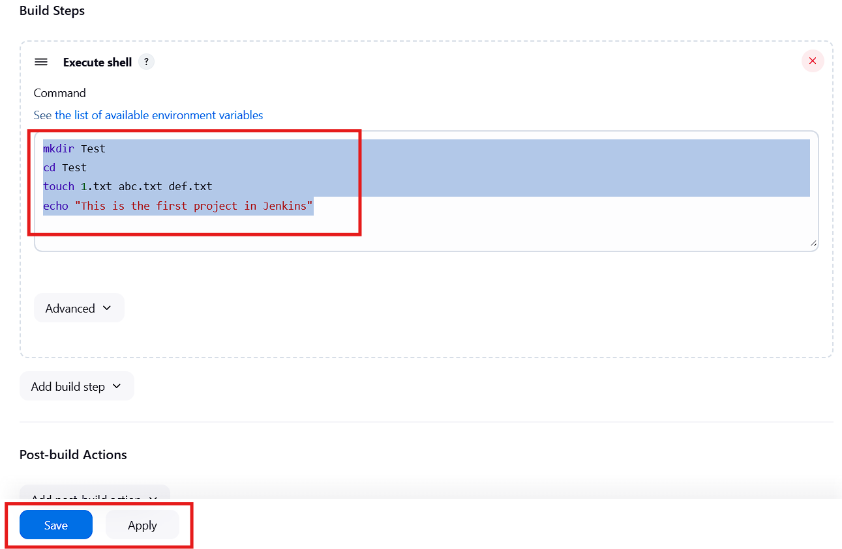  
  
  
Click on build now   
  
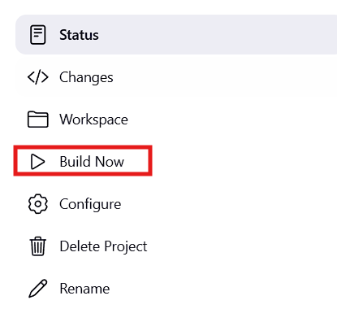  
  
Now login to your Jenkins machine go to cd /var/lib/jenkins/workspace  
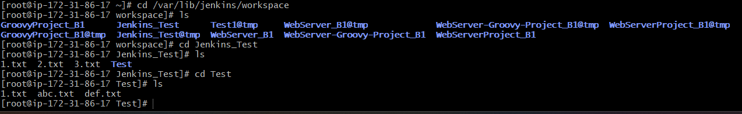  
  
Go to your job folder, where you will see the files and folders created from the 'Execute Shell' build step.